EXPT NO:3 | CLEANSE DATA BY HANDLING MISSING VALUES, OUTLIERS, AND INCONSISTENCIES USING TABLEAU AND POWERBI
DATE: 10.07.2026

NAME: Akhil C
Roll No: 24BAD007

PRE-LAB QUESTIONS (PROVIDE BRIEF ANSWERS TO THE FOLLOWING QUESTIONS)
- What are the potential impacts of missing values in a dataset, and what are some common strategies to address them in Tableau and Power BI?

Missing values can reduce data accuracy and lead to incorrect analysis. Common strategies include replacing missing values with the mean, median, or default values, filling text fields with "Unknown," or removing incomplete records using Tableau and Power BI tools.

- What is the importance of identifying and addressing outliers in a dataset? How can outliers affect data analysis and model performance?

Common inconsistencies include spelling errors, duplicate values, inconsistent text formatting, different date formats, and incorrect data types. Tableau uses Aliases and Groups, while Power BI uses Replace Values and Power Query to standardize the data

- What types of data inconsistencies might you encounter during data cleansing, and how can Tableau and Power BI help in resolving them?

Common inconsistencies include spelling errors, duplicate values, inconsistent text formatting, different date formats, and incorrect data types. Tableau uses Aliases and Groups, while Power BI uses Replace Values and Power Query to standardize the data.

- How do you identify patterns in data using visualizations to spot missing values, outliers, and inconsistencies?
Visualizations such as scatter plots, box plots, histograms, and bar charts help identify missing values, detect outliers, and reveal inconsistent data pattern

- What is the role of calculated fields in data cleansing, and how can they be used to handle missing values and outliers in Tableau/Power BI?
Calculated fields create new values based on existing data. They can replace null values, flag outliers, standardize data, and perform calculations needed for data cleaning.

IN-LAB EXERCISE:
OBJECTIVE:
To clean a given dataset (e.g., Superstore Sample in Tableau and Financials/Sales Data in Power BI) by identifying and resolving missing values, outliers, and inconsistencies using built-in tools, ensuring the dataset is accurate and ready for analysis.

PROCEDURE:

Open the Tool and Connect Dataset
    - Open Tableau Desktop , Power BI Desktop.
    - Load the built-in dataset (Sample - Superstore in Tableau / Financials in Power BI).
    - Preview the dataset to understand its structure.

Initial Inspection
    - Explore fields such as Sales, Profit, Region, or Product Category.
    - Check for nulls, inconsistent text values (e.g., "South Region" vs. "South"), or date formatting issues.

Handling Missing Values
    - Use Data Interpreter (Tableau) / Power Query (Power BI) to highlight nulls.
    - Replace missing numerical values with mean/median, and text with "Unknown".
    - Use calculated fields: IFNULL([Field], Default) in Tableau or IF(ISBLANK([Field]), "Unknown", [Field]) in Power BI.

Detecting and Managing Outliers
    - Create scatter or box plots for Sales and Profit to identify extreme values.
    - Choose strategies:
      - Filter them temporarily.
      - Apply caps using calculated columns.

      - Flag them with labels for review.

Resolving Inconsistencies
    - Use Group/Alias (Tableau) / Replace Values (Power BI) to standardize text.
    - Normalize data formats, such as date fields or currency units.

Validation with Visuals
    - Build dashboards with histograms, bar charts, and box plots to visually confirm improvements.
    - Compare before/after cleaning stages for accuracy.

Save the Cleaned Dataset
    - Save as .twbx (Tableau) / .pbix (Power BI).
    - Optionally export cleaned data to .csv.

Summary Dashboard
    - Create a visual summary of the cleaning process, highlighting:
      - Fields corrected.
      - Nulls/outliers removed or adjusted.
      - Clean dataset metrics (record count, completeness %).

Experiment Dataset:
- Tableau: Sample - Superstore
- Power BI: Financials or Sales Data

How to Access:
Tableau:
  - Navigate to: Start Page → Sample Workbooks
  - Or: Help → Sample Data → Open Sample Data Folder
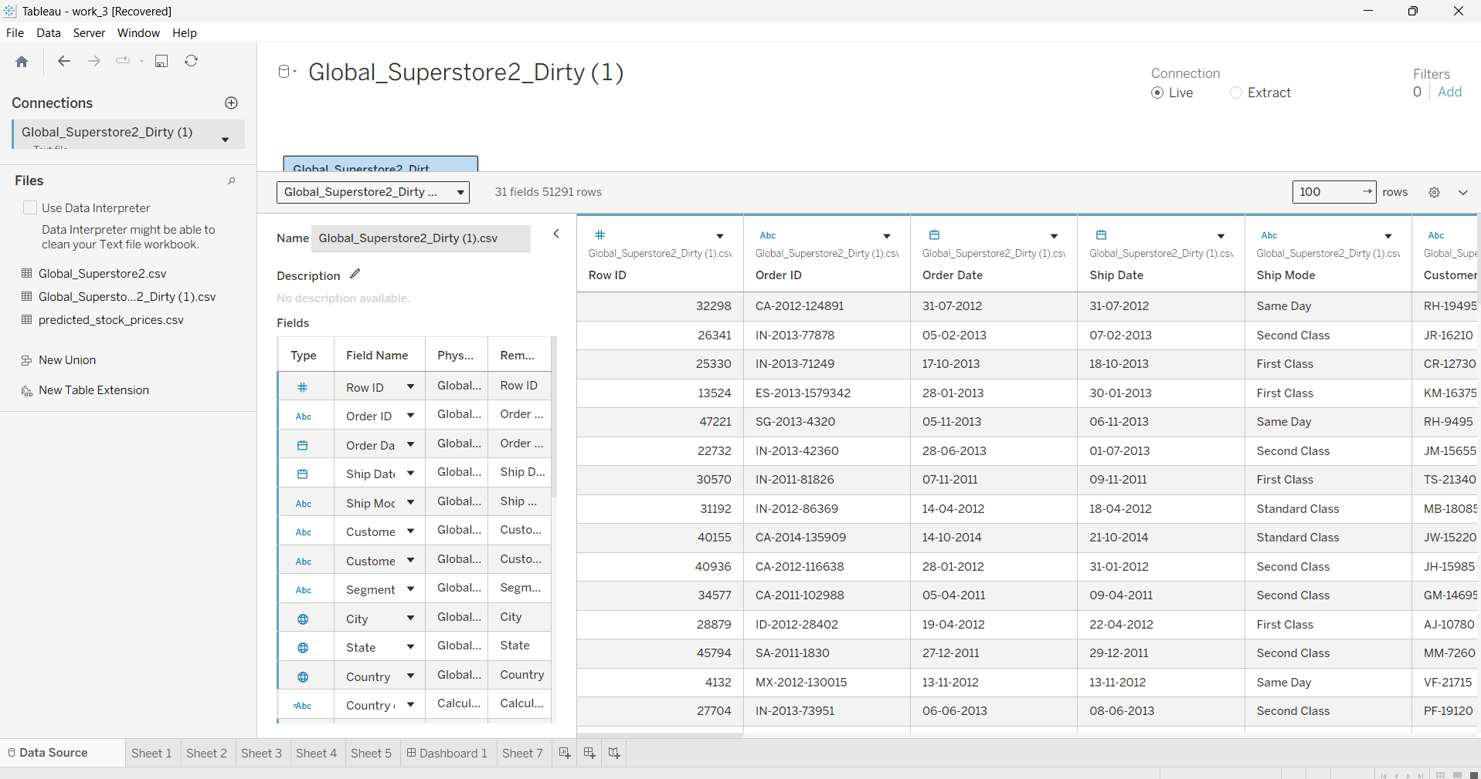
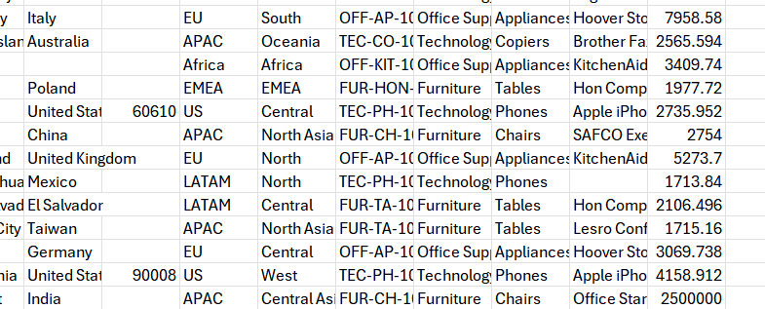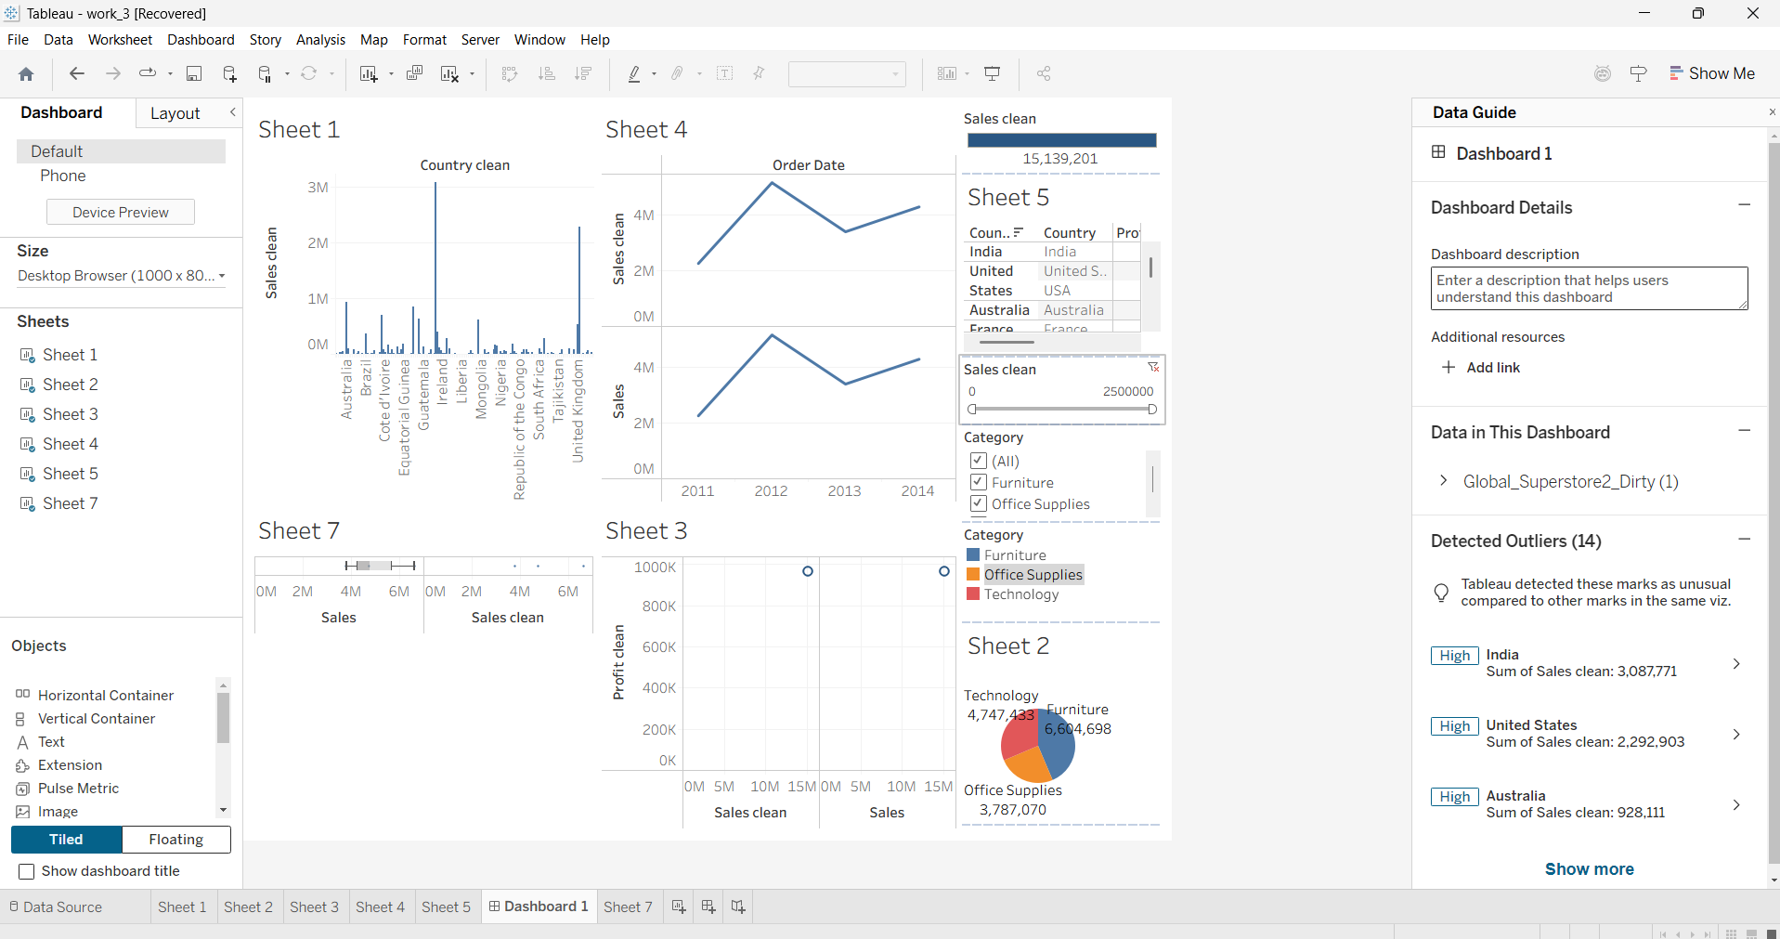

Power BI:
  - Navigate to: Home → Get Data → Excel → Choose sample datasets (e.g., Financial Sample.xlsx)
  - Microsoft also hosts Power BI sample datasets online.

Fields Used:
- Sales
- Profit
- Region
- Category

- Order Date / Transaction Date
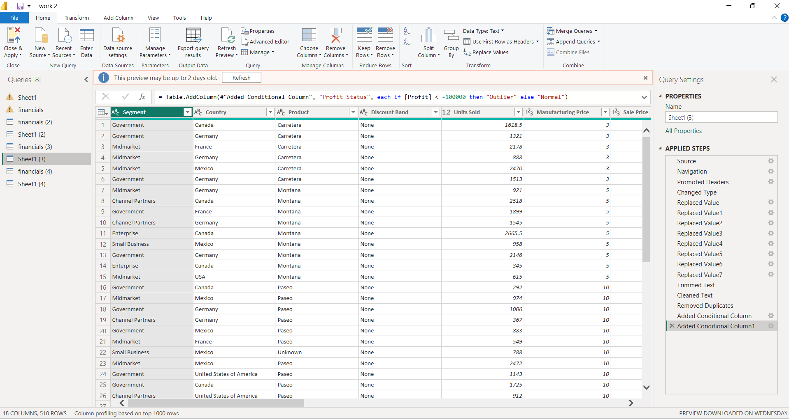
- 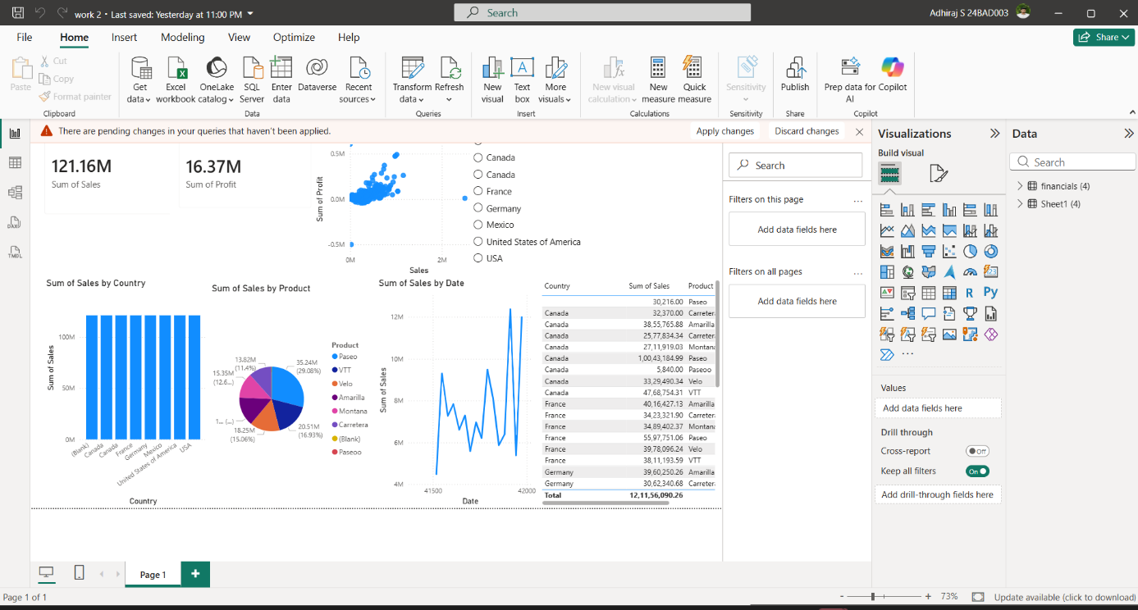

POST-LAB QUESTIONS (PROVIDE BRIEF ANSWERS TO THE FOLLOWING QUESTIONS)
- What method did you use to replace missing values in numeric fields?
Missing numeric values were replaced using the mean (average) of the respective column. In Tableau, the IFNULL() function was used, while in Power BI, Power Query or DAX functions were used.

- How were outliers handled in your dataset and what visual confirmed their correction?
Outliers were identified using scatter plots and box plots. Extreme values were filtered, capped, or flagged for review. The updated box plot confirmed that the outliers had been handled correctly

- What inconsistencies were detected in categorical values and how were they standardized?
Inconsistencies such as different spellings (e.g., "South Region" and "South"), extra spaces, and inconsistent capitalization were identified. They were standardized using Aliases/Groups in Tableau and Replace Values in Power BI.

- Describe how calculated fields helped in resolving data issues.

Calculated fields were used to replace null values, identify outliers, standardize values, and create new fields for accurate analysis and reporting.

- How did your dashboard demonstrate the effectiveness of the data cleaning process?

The dashboard displayed cleaned data using charts and KPIs, showing reduced missing values, corrected inconsistencies, and improved data quality. Comparing the data before and after cleaning confirmed the effectiveness of the process.

RESULT:

The dataset was successfully cleaned and prepared for accurate analysis using Tableau and Power BI. Issues such as nulls, inconsistencies, and outliers were identified and resolved, improving data quality significantly.

ASSESSMENT

Description | Max Marks | Marks Awarded
Pre Lab Exercise | 5
In Lab Exercise | 10
Post Lab Exercise | 5
Viva | 10
Total | 30
Faculty Signature

